|  |
| --- |
|  |
| Fly Away Airline Ticket Reservation System |
| [User Guide Documentation] |
| |  |  |  | | --- | --- | --- | | Cheekuri Mahesh | 1/29/21 | SimpliLearn – Phase 2 Project | |

**Admin Flow Chart Diagram**

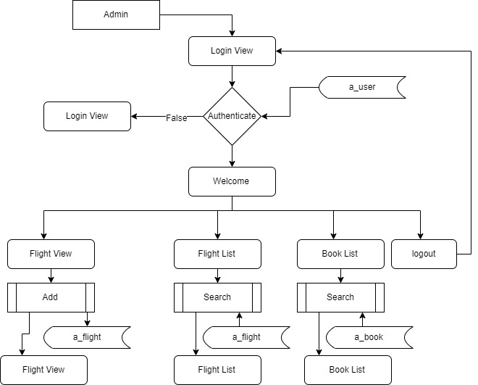

**User Flow Chart Diagram**

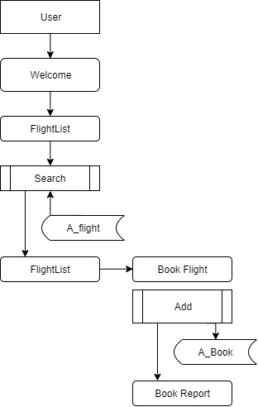

**Project Workflow**

**Welcome Screen**

This screen has the Company Name along with few options for the user to Navigate to different pages as per their requirements.

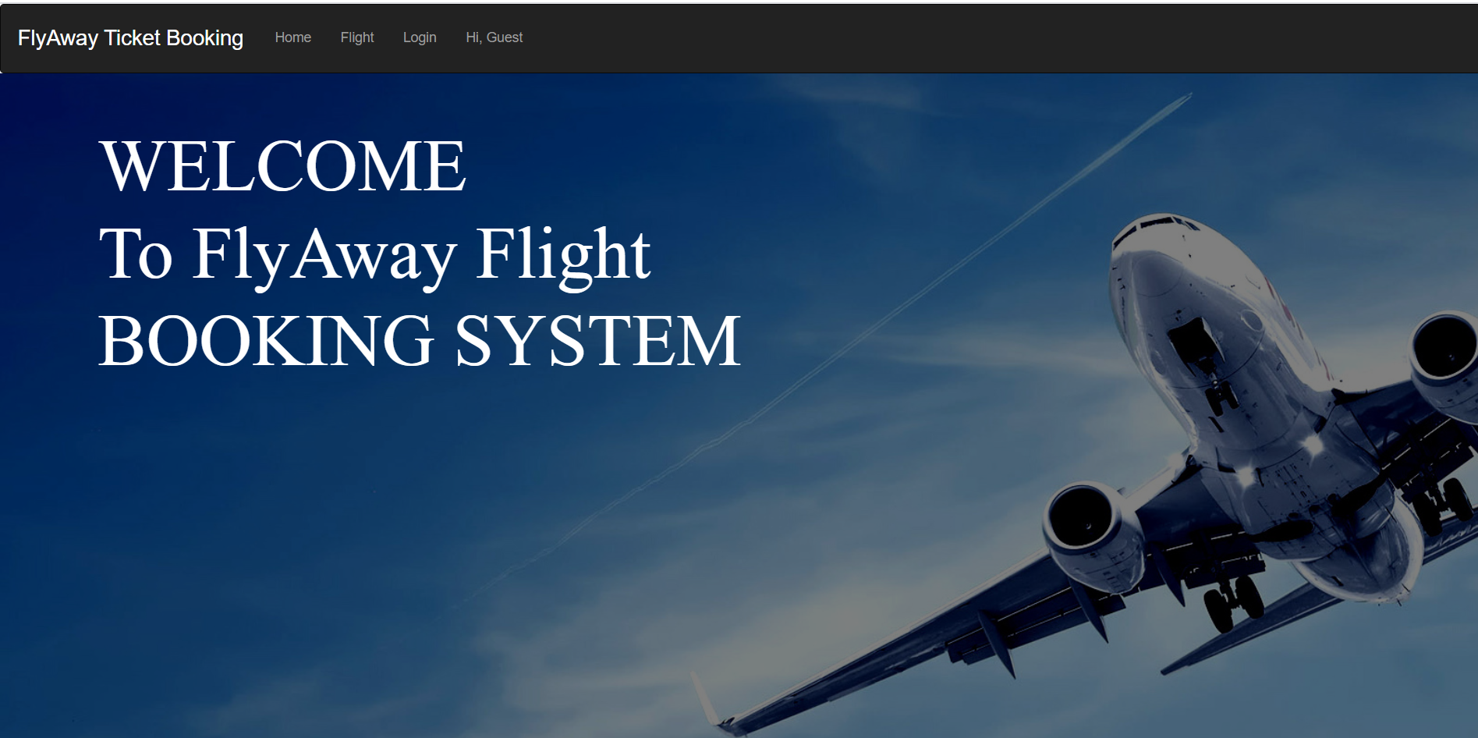

**Login Page**

In this Login Page the guest has to two options:

* Guest can login using their credentials
* Guest can newly register themselves to the web page by creating a new login credentials.
* To get the Admin Privileges Admin can login using the same login Page but with the Admin Credentials

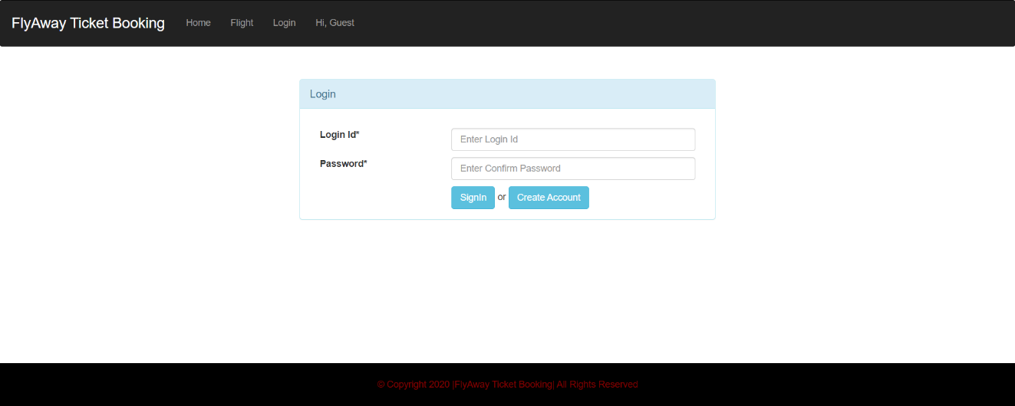

**Admin Workflow**

The Admin Credentials are:

* Login ID: [Admin@gmail.com](mailto:Admin@gmail.com)
* Password: Admin@123

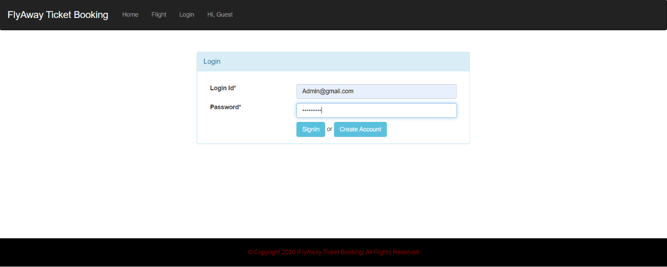

**Admin Welcome Screen**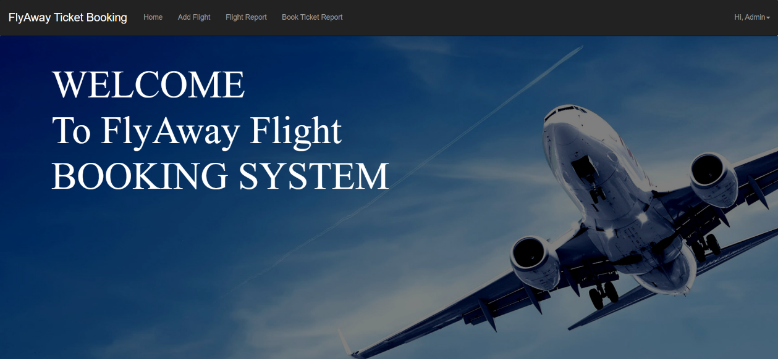

As soon as the Admin logged in, Admin has the access to do the following operations mentioned below:

* Add Flight – Admin can Navigate to Add flight page where he can fill in flight details and add it

As soon as the Admin is Navigated to Add Flight page, then he needs to fill all the details of the flight

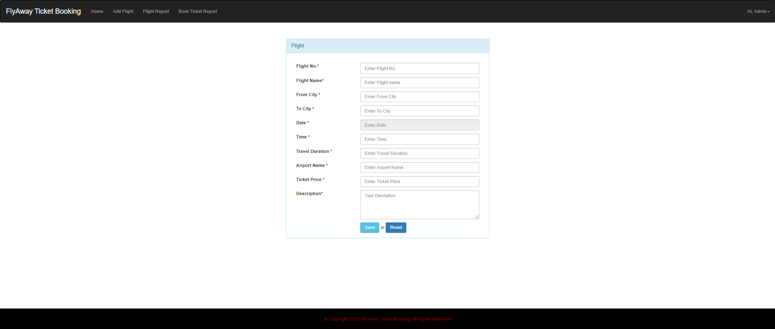

As soon as this page appear then the details of the new flight is entered and Save button is clicked

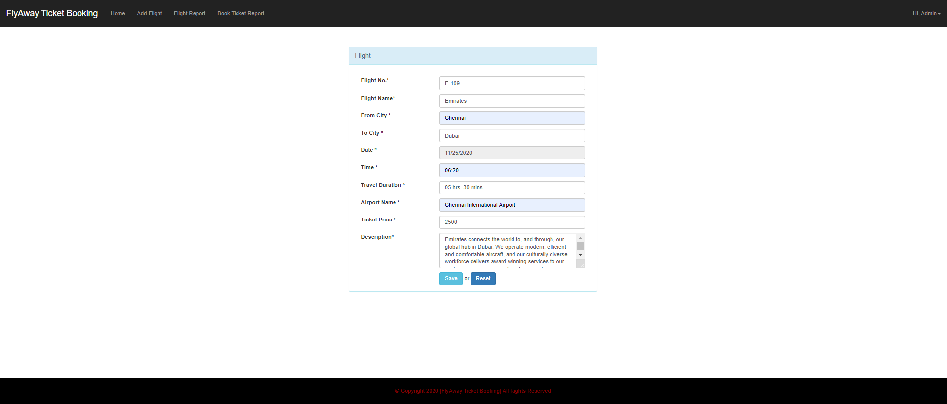

* Flight Report – In this Page the admin can see all the flights currently is available for the booking

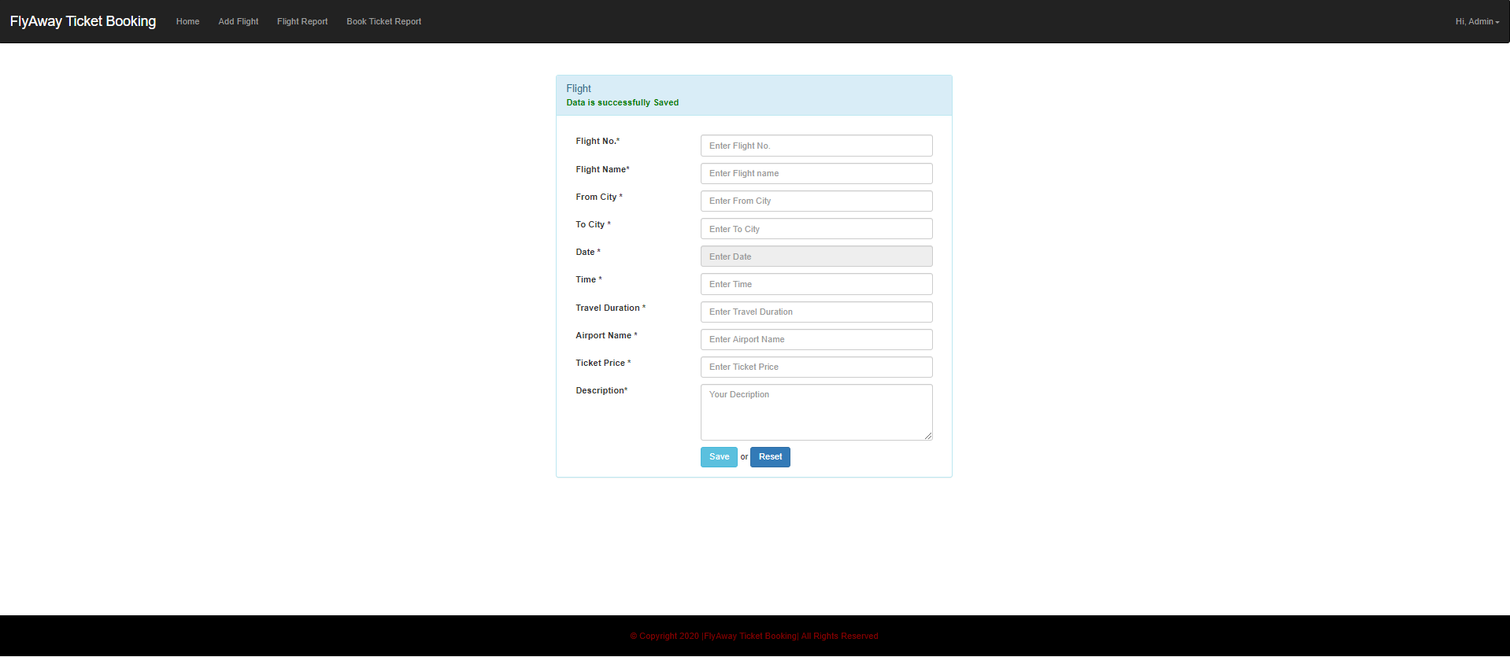

* Book Ticket Report – In this page Admin can see the booking details of the tickets

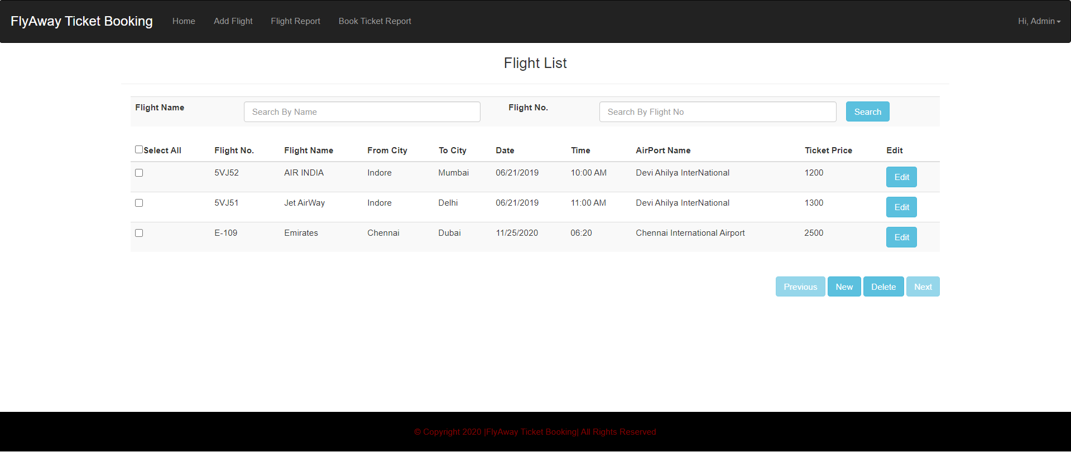

**Delete flight detail**

* The Admin has an option to delete the flight detail by selecting the flight details by checking the check box and clicking the delete button to complete the action

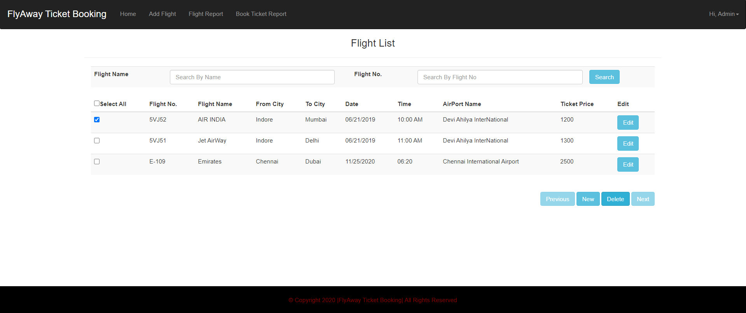

**Data deletion successful**

* Once the selected flight ticket is deleted then there is a message to make the user know that the data is deleted successfully as shown in the below screenshot

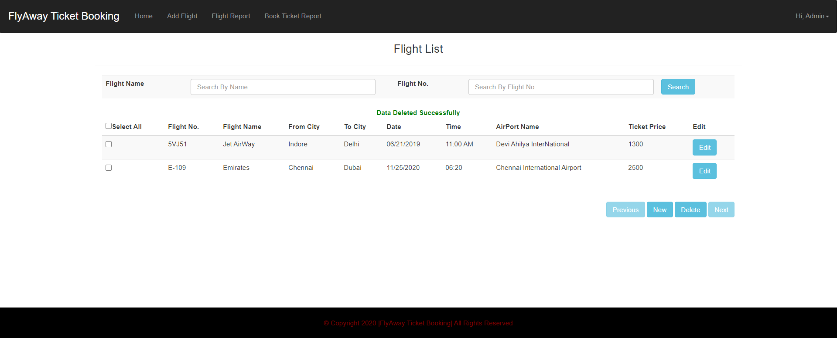

**Edit flight details**

To Edit the flight details of a particular flight the Admin has to click the Edit button available on each item of the list and click it to display all the details of the particular selection where Admin can Update the Details of the Flight

**Time duration was edited from 1hr 50mins to 1hr 45mins:**

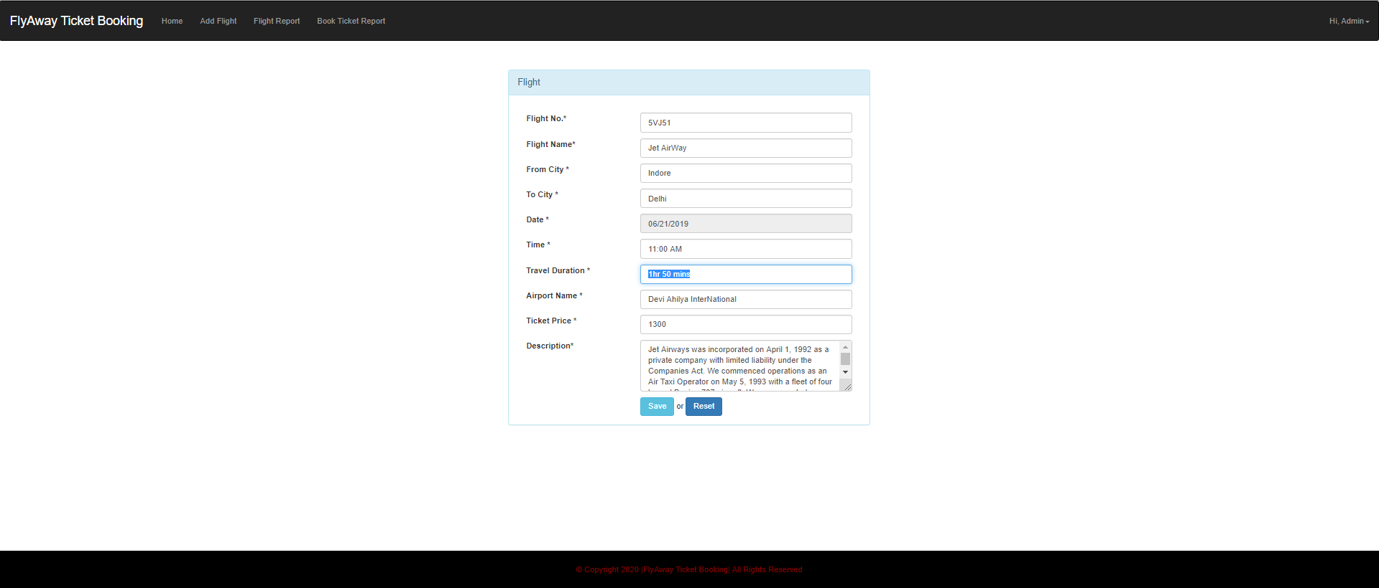

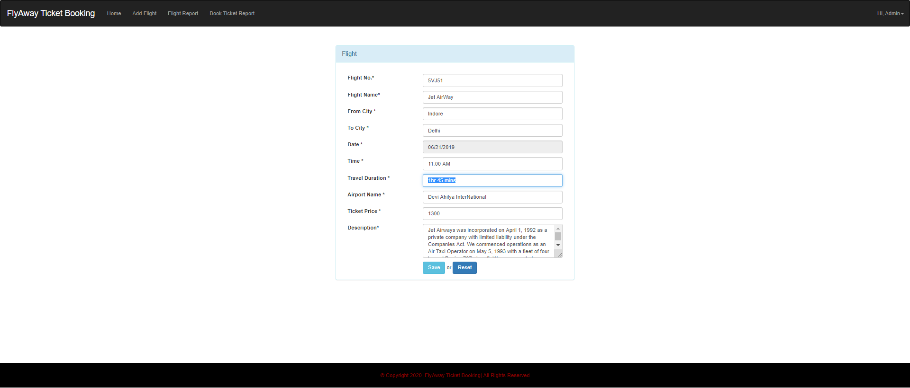

**Edited detail has been updated successfully:**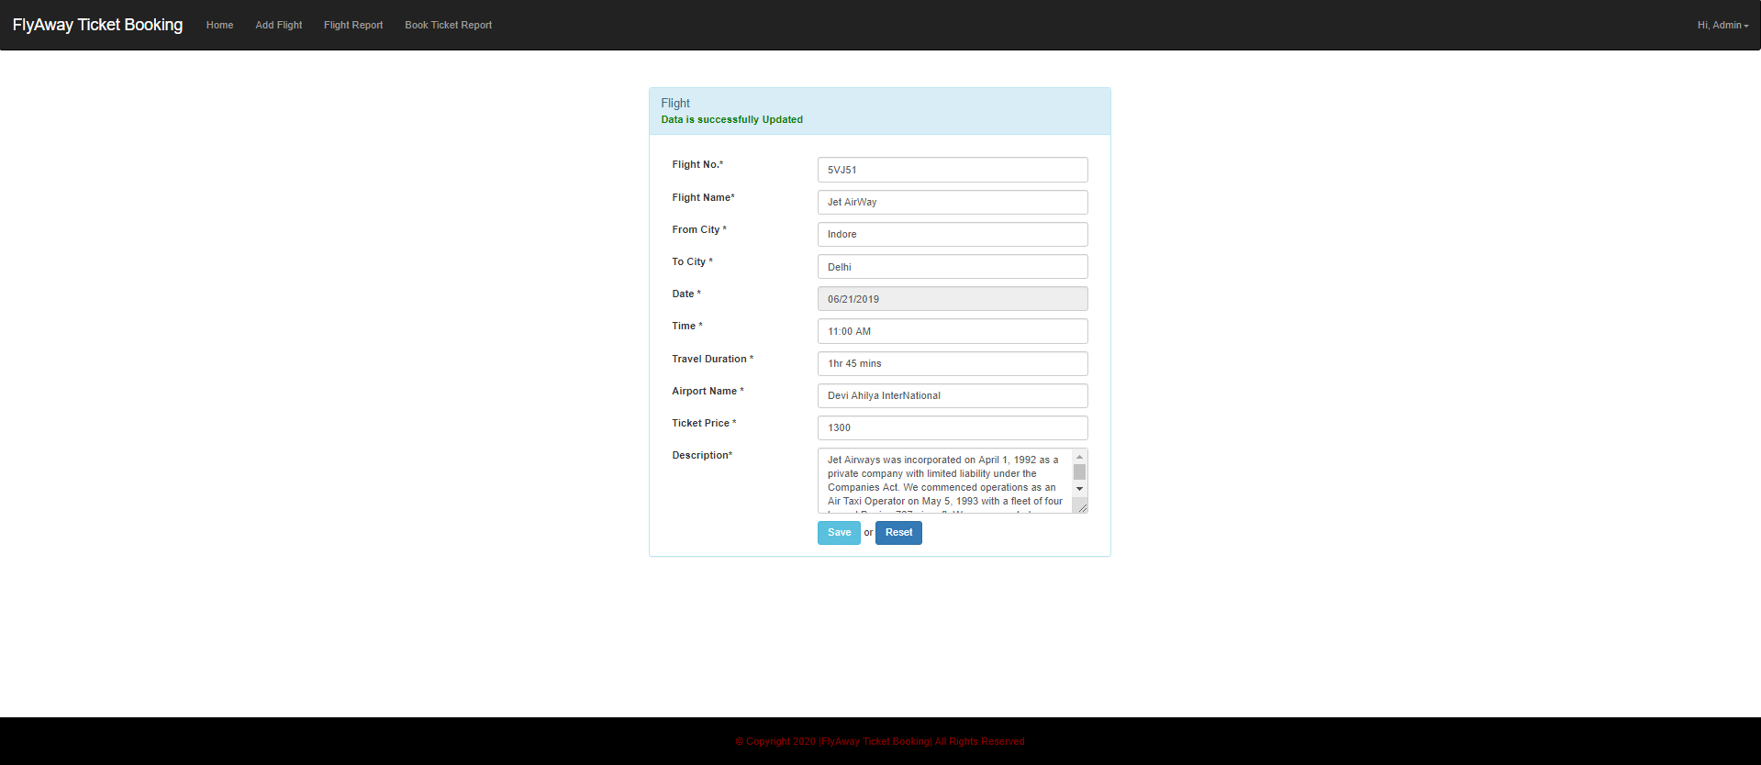

**Filter option**

There are few Filter options which are implemented for searching the appropriate flight for the Admin to make update to the details of the flight or even deleting it etc.

Below are the few Filter options namely for the Admin Credential

* Filter by Flight Name
* Filter by Flight Number

**Filter by flight name:** 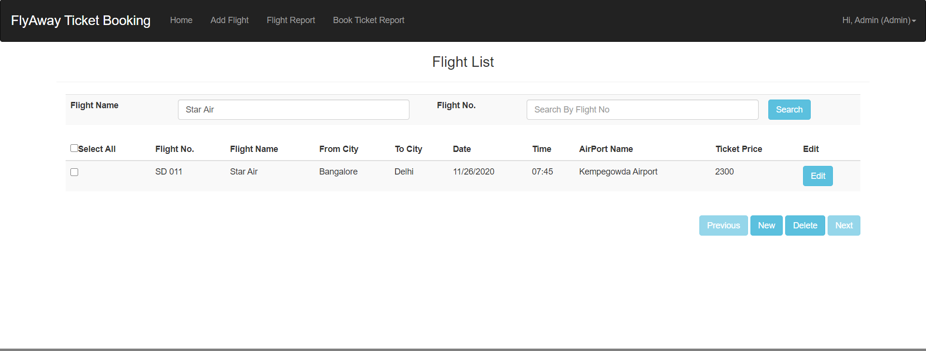

**Filter by flight number:**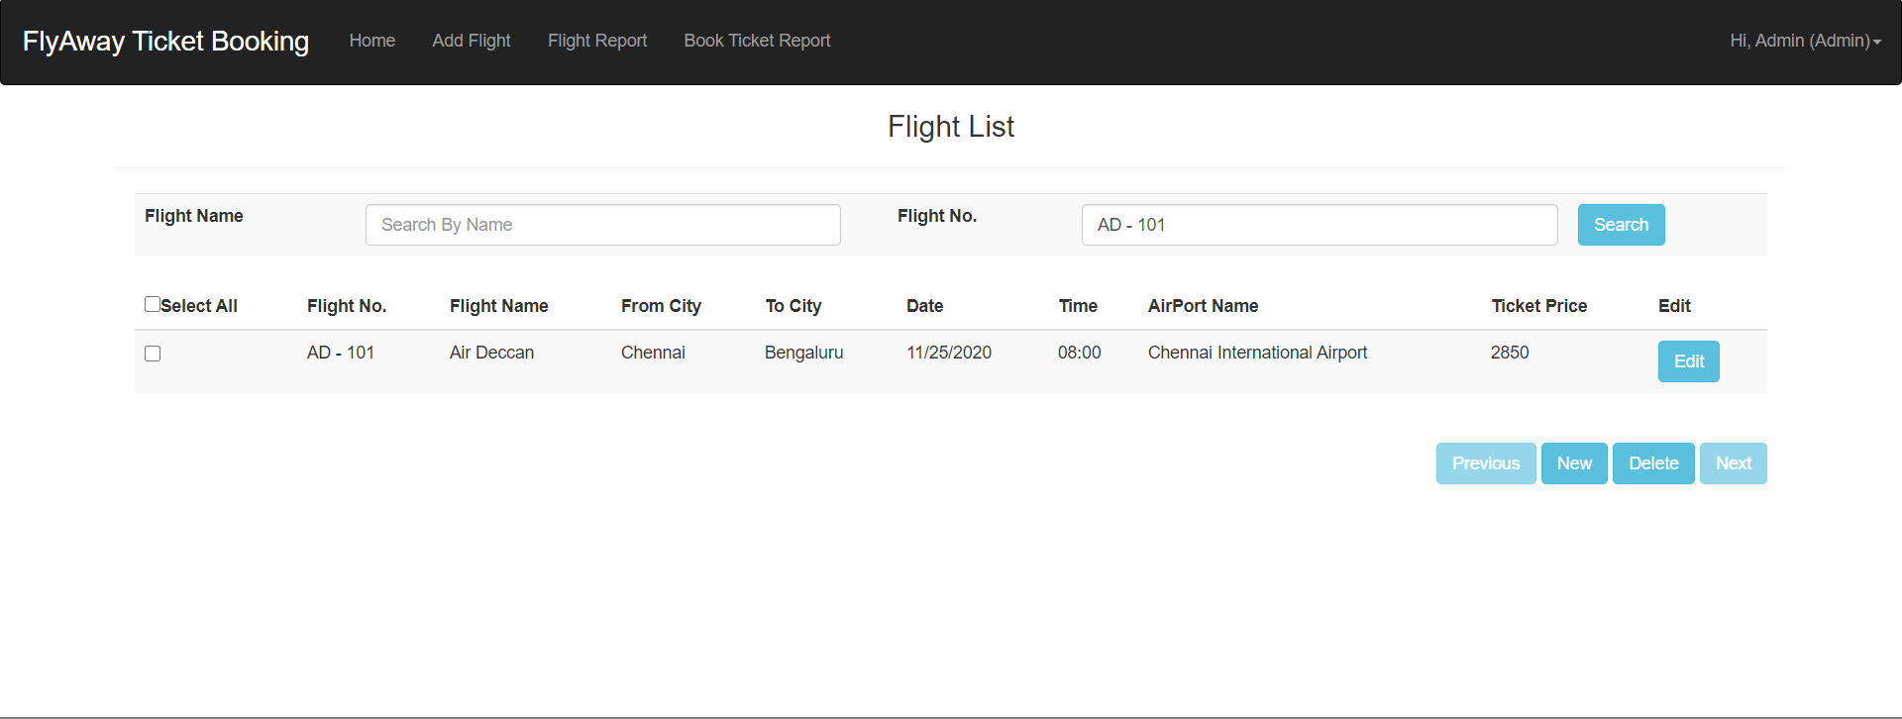

**Book Ticket Report**

The booked report of the all the users have been listed out for the Admin to view the bookings made.

* If there are any details of the bookings then the bookings are listed out with the details of the user along with the Flight details booked
* If there are no records booked yet by any user then the message No Records Found message

Below are the Images to show the view of both the views

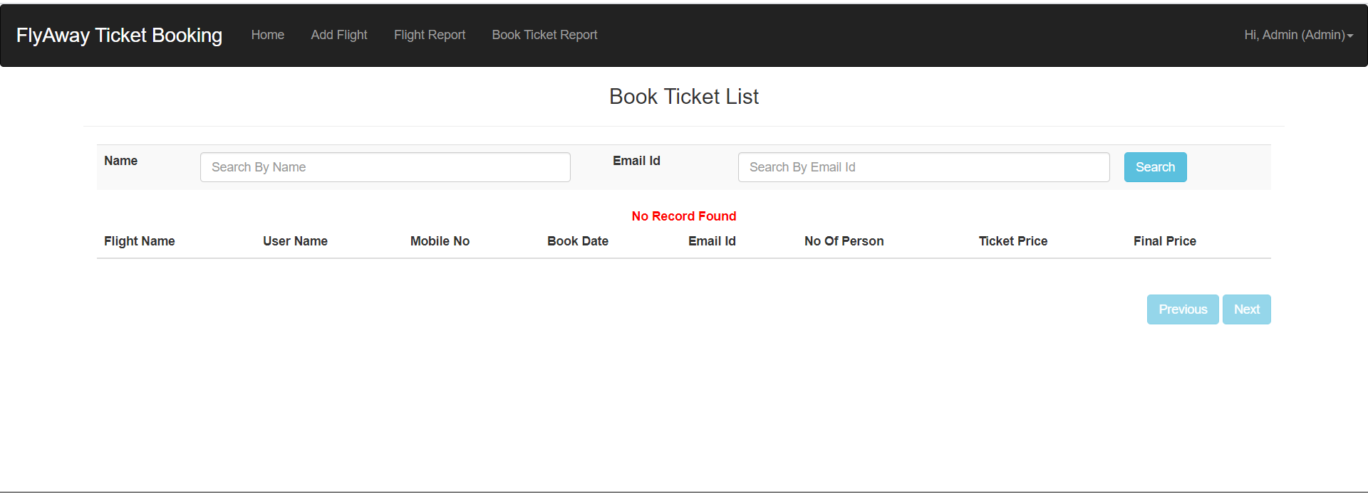

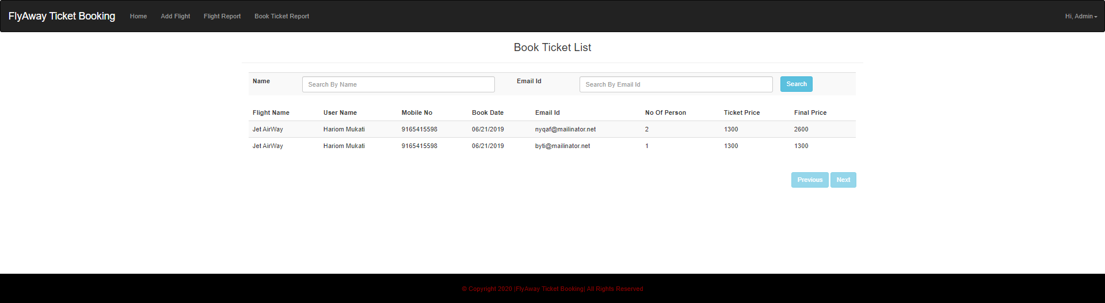

**Log out as Admin:**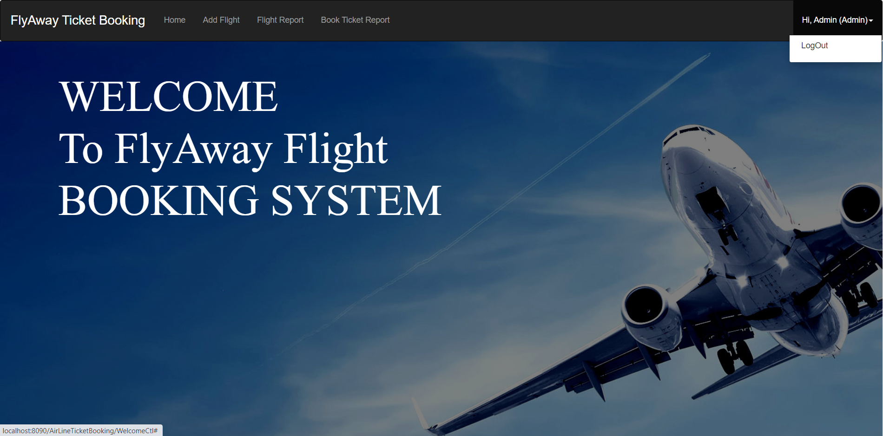

**Logged out successfully:**

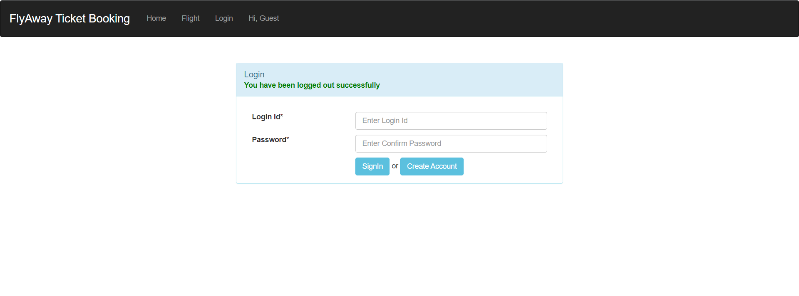

**Login as Guest:**

As soon as a Guest loads into the application, A Guest they have to login to the application or has to create an account in order to book the tickets of flights from the Flyaway Reservation system

**Create an account for the user:** 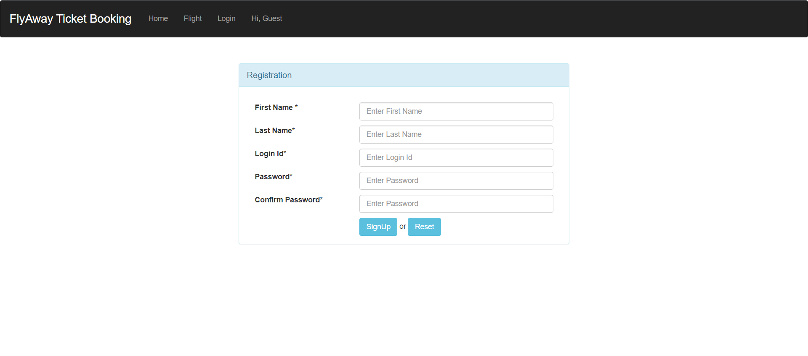

**Entered user details**

The User details has been entered with the details of the user sufficient to identify unique the user and have to signup to add the user details to the database

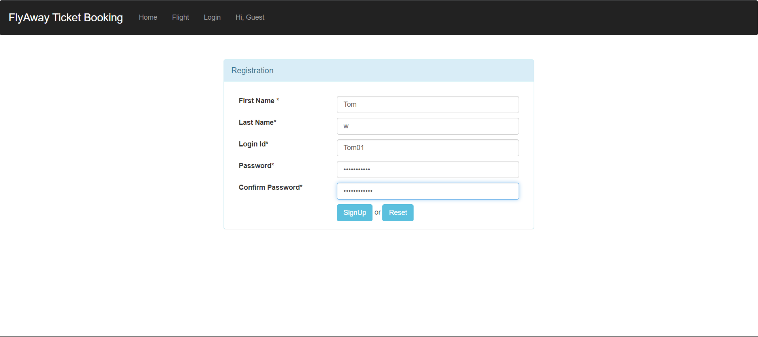

**User successfully added:**

After the User successfully Signup with the details entered as per the validations then User Successfully Registered message appears and the details are successfully Added

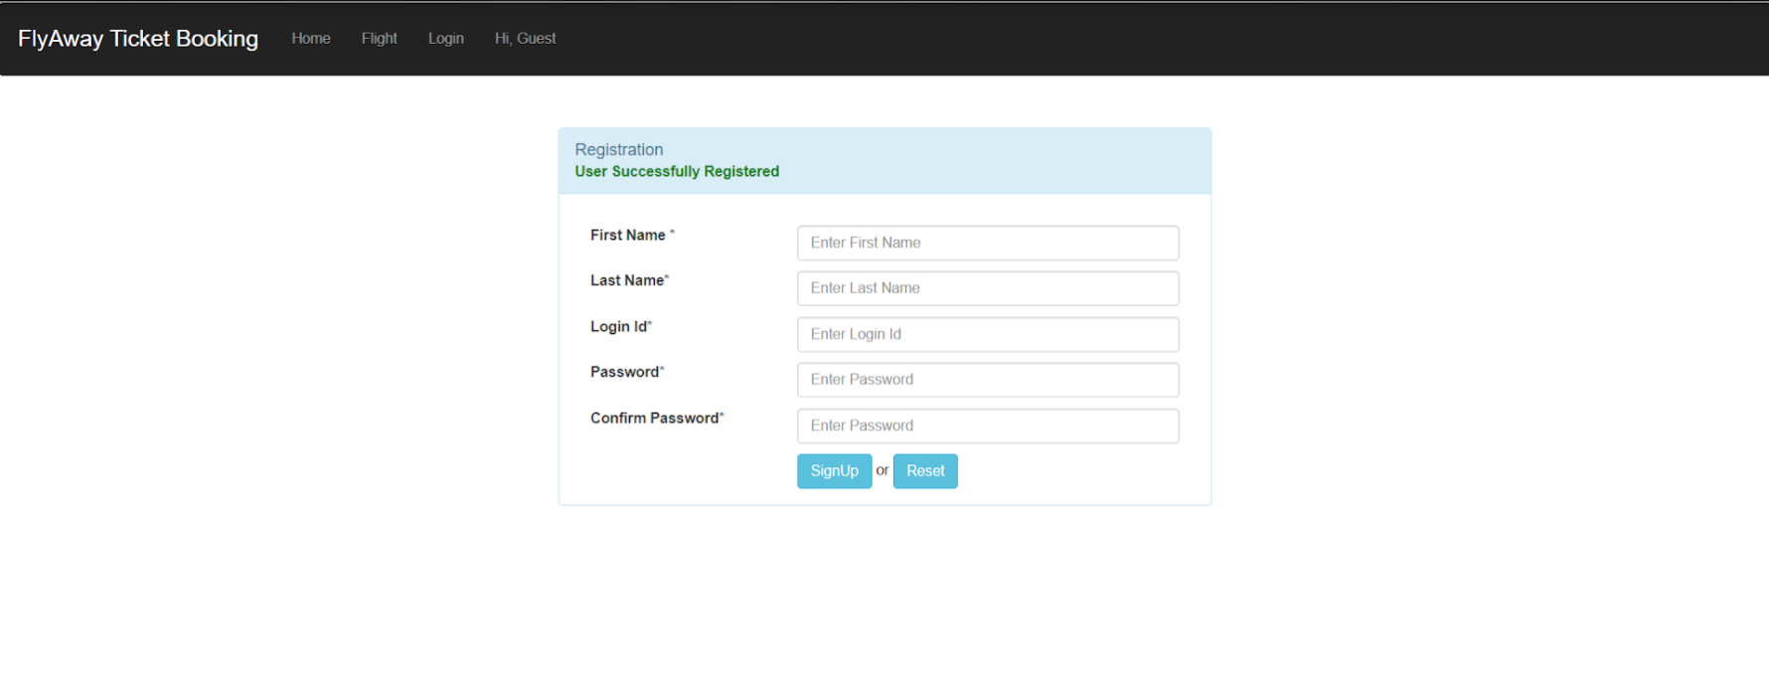

**Login as User:**

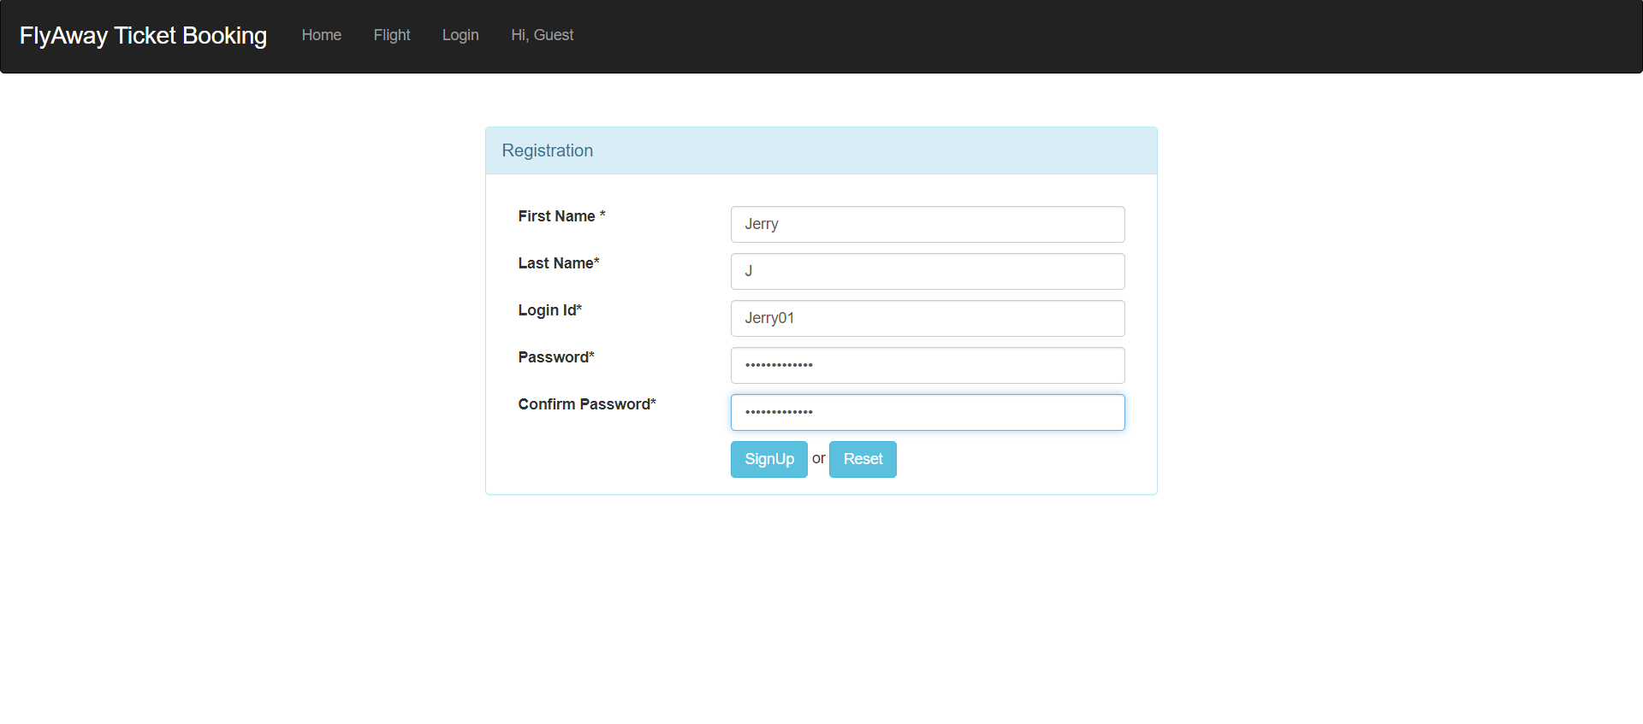

**User views the flight list:**

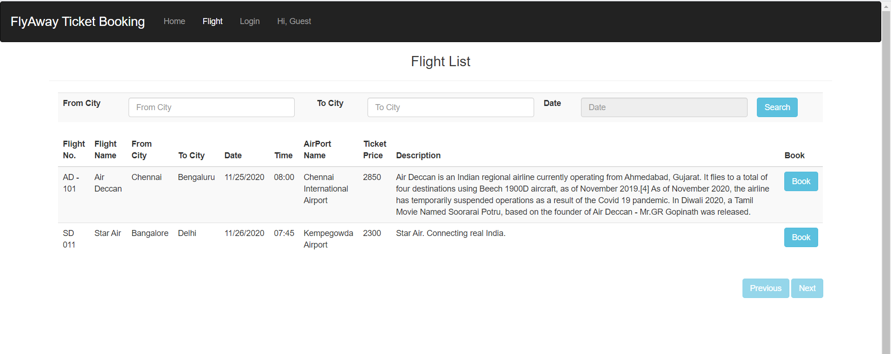

**User to filter flight details with City name:**

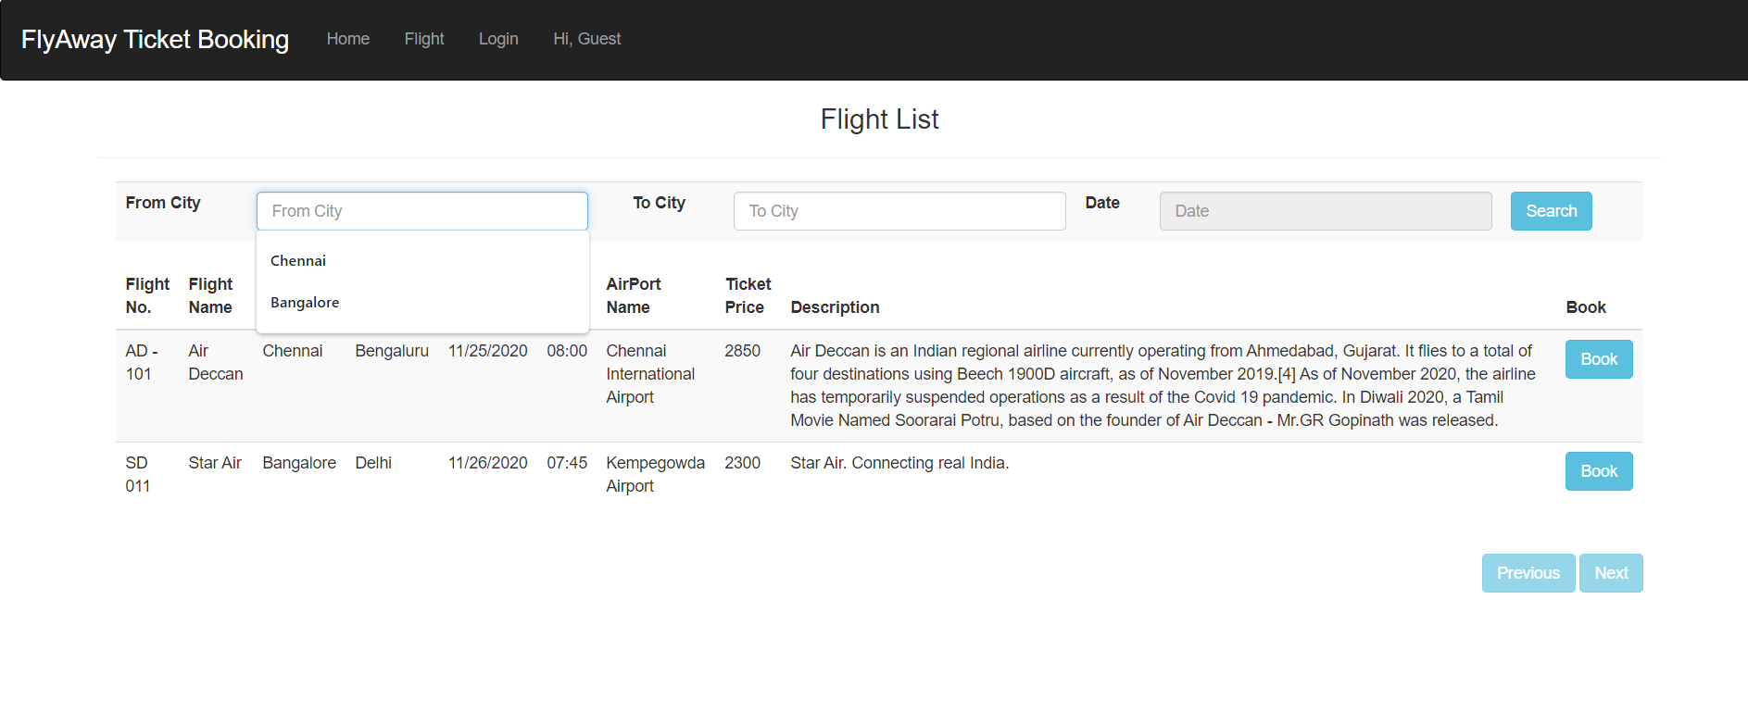

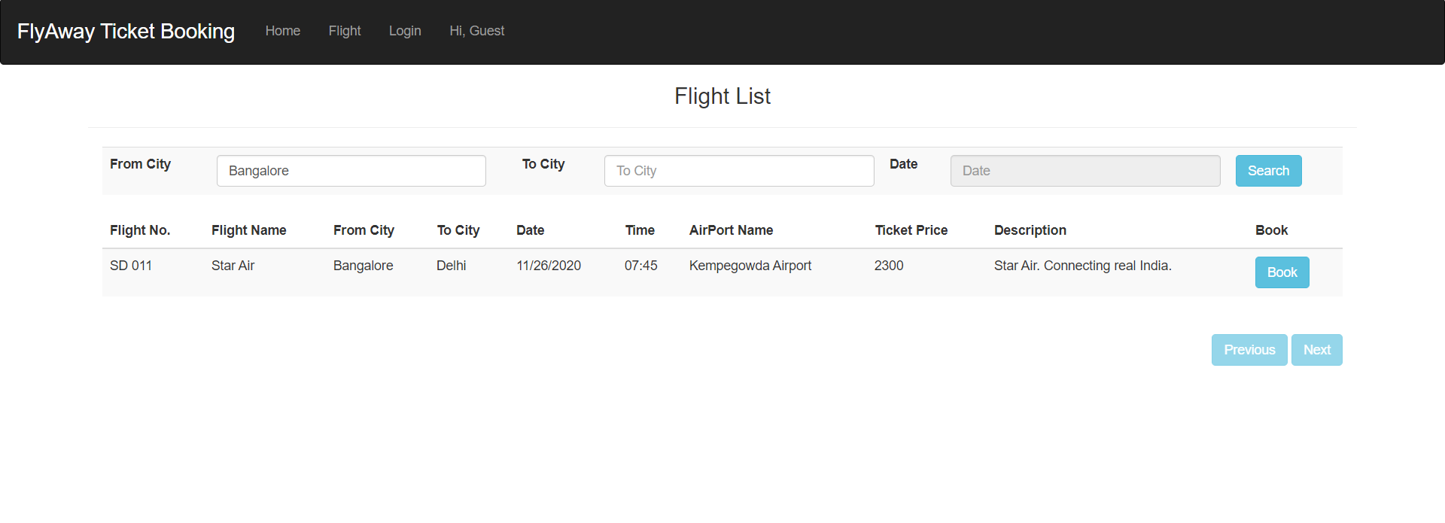

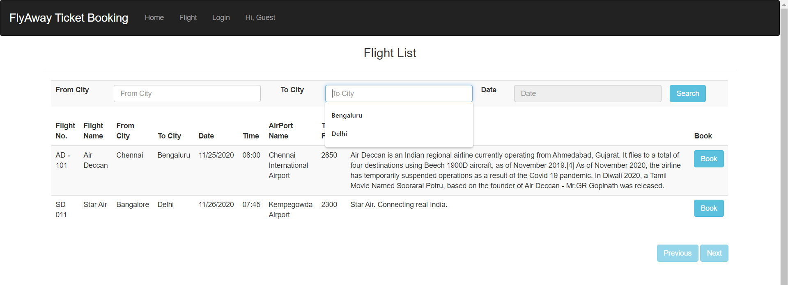

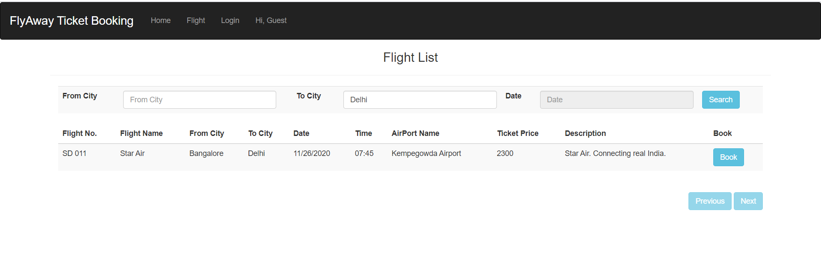

**Book a flight:**

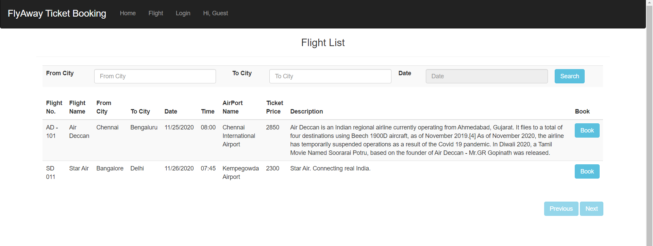

**User logs in to book flight ticket:**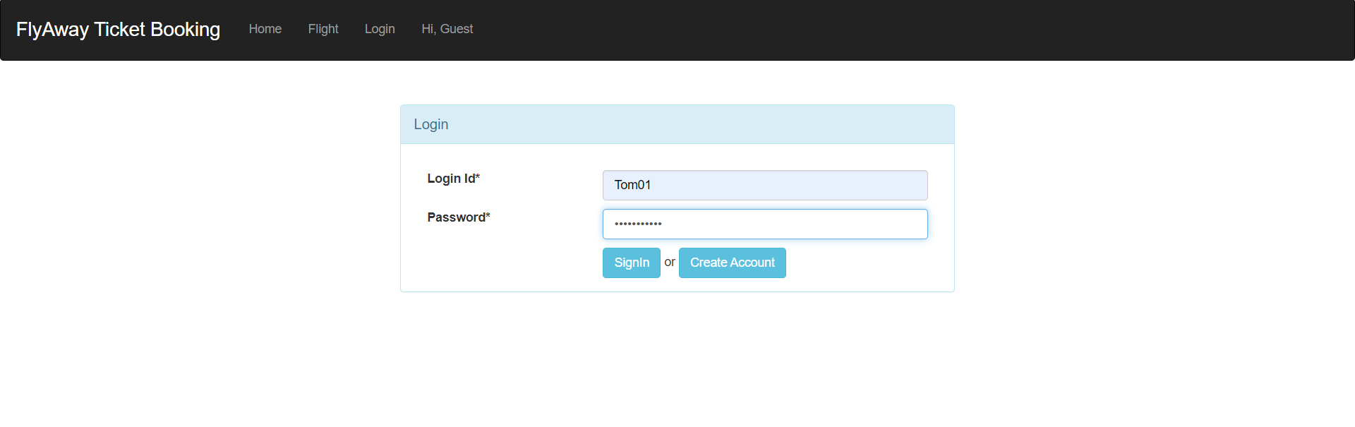

**More user details to be entered:**

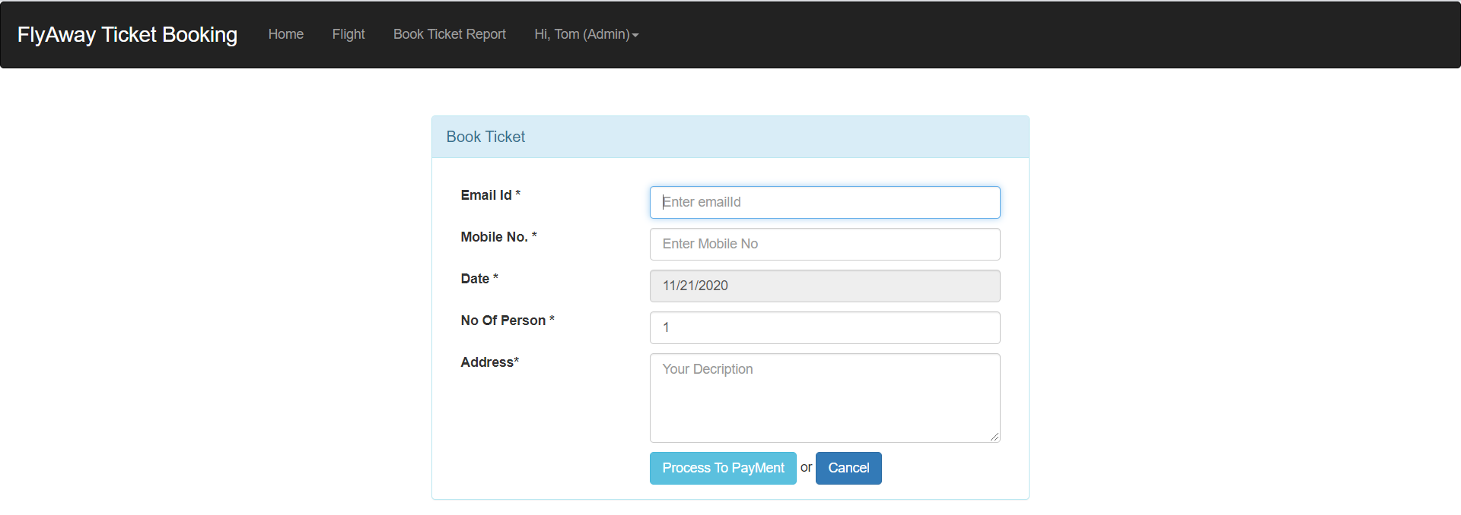

**Details entered by the user:**

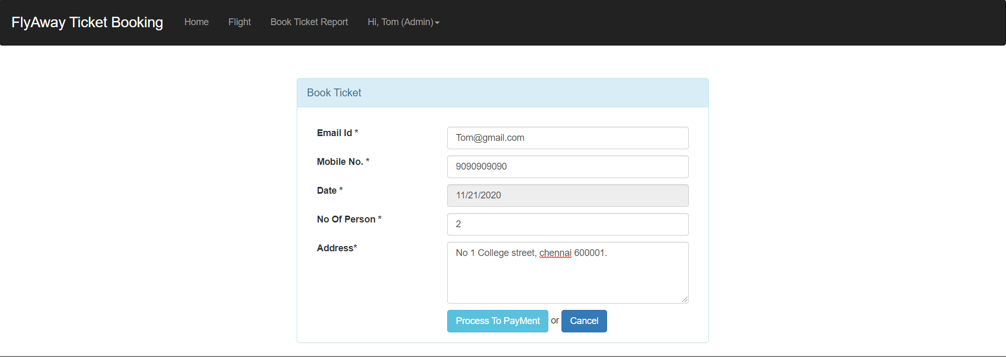

**Confirm details displayed:**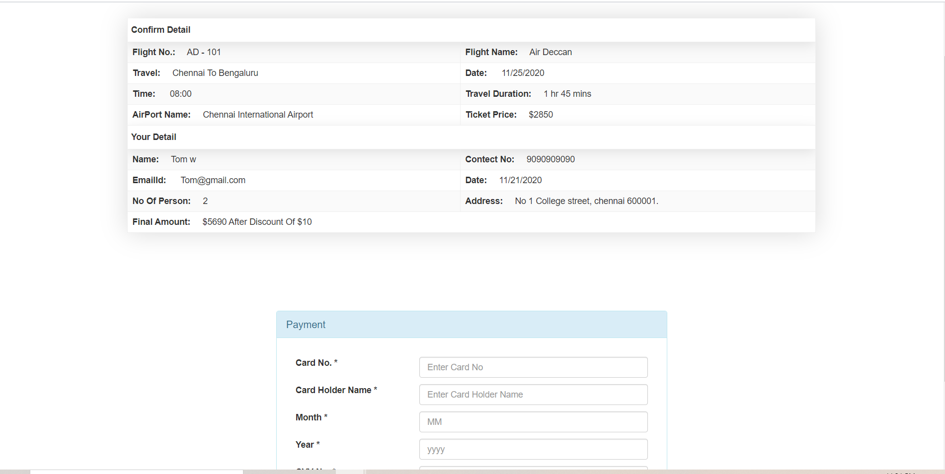

**Payment details entered:**

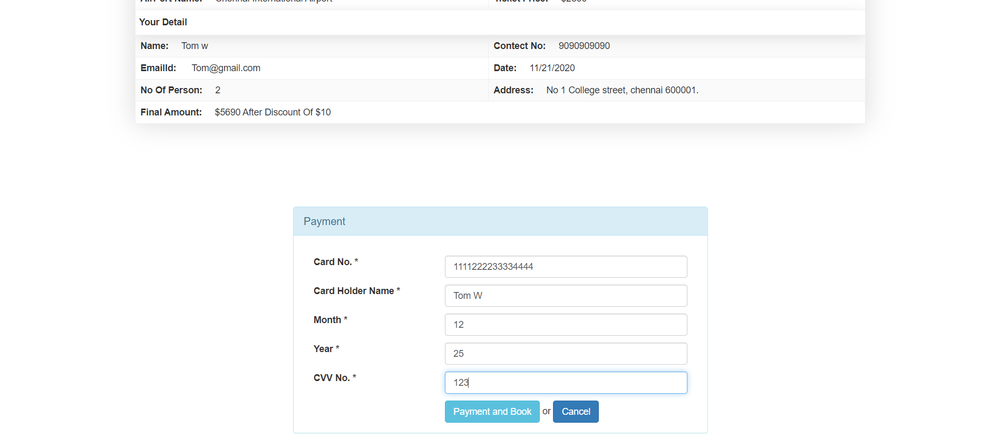

**Ticket is booked successfully:**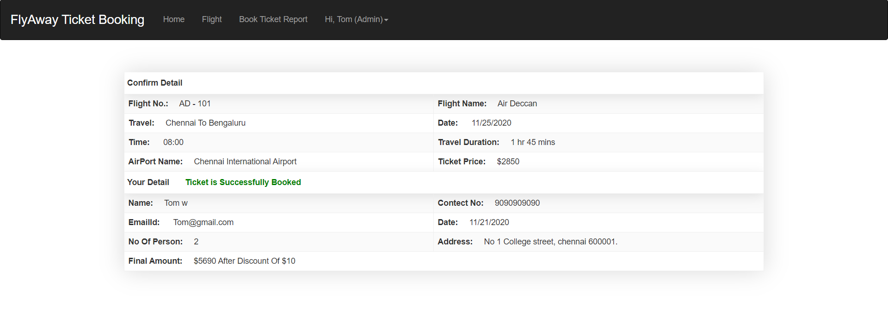

**Passenger with flight details:**

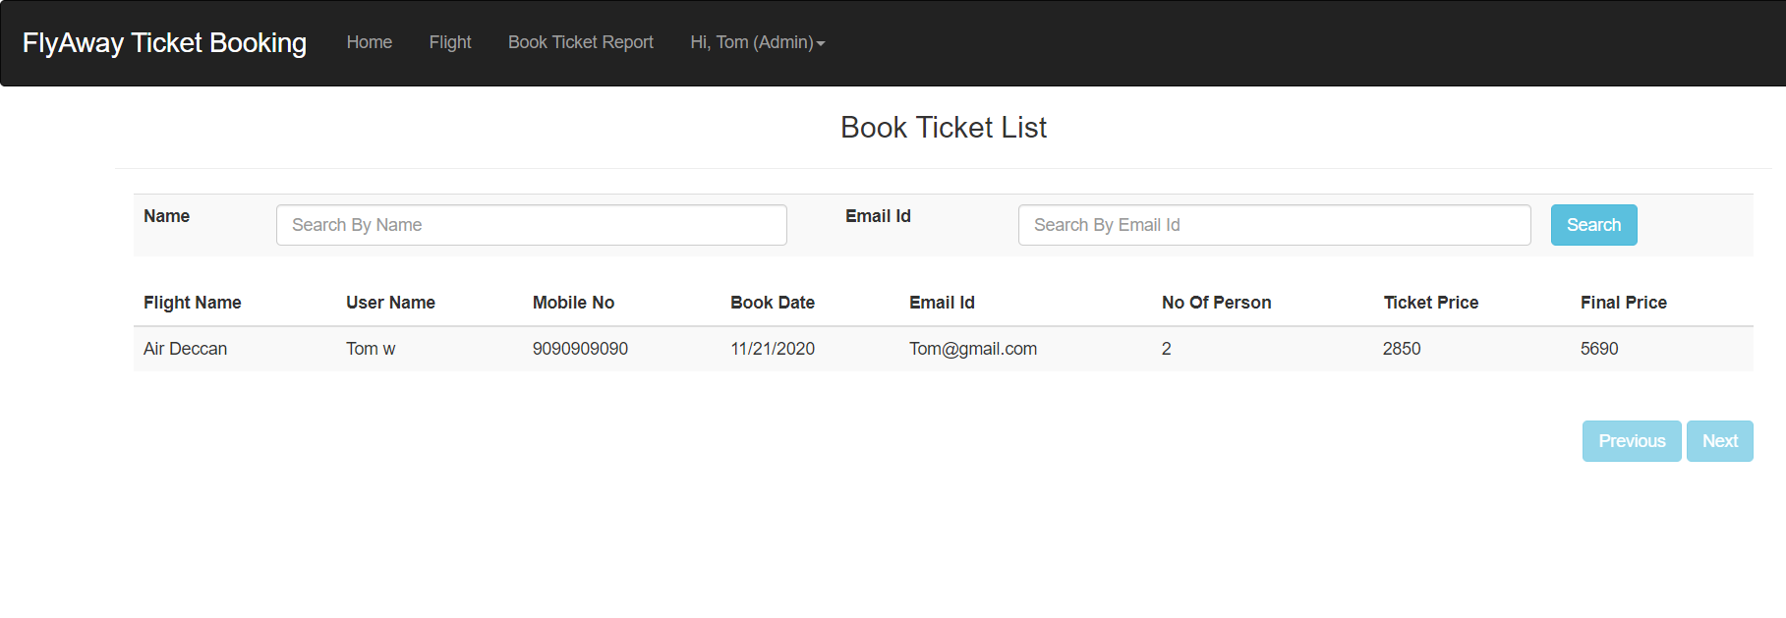

**\*\*\*\*\* Thank you \*\*\*\*\***